**Roll No.: 24BCS054 Name: Dawood Abdul Basith J**

**KUMARAGURU**

COLLEGE OF TECHNOLOGY

**LABORATORY WORK BOOK**

**Exercise/Experiment Number:1**

**Lab Code / Lab :** **P20CAP1502 - Data Structures Lab Using C**

**Course / Branch : I MCA**

**Title of the exercise/experiment : Programs using Linear Search and Binary Search**

**Algorithms**

______________________________________________________________

**1. Problem Statement:** When the city planners developed your neighborhood, they accidentally numbered the houses wrong. As such, the addresses of the houses on the street are in a random order. Write a program using linear search algorithm to help the postman find a house.

Program:

#include <stdio.h>

int linearSearch(int houses[], int size, int target) {

for (int i = 0; i < size; i++) {

if (houses[i] == target)

return i; // Return the index (position) if found

}

return -1; // Return -1 if not found

}

int main() {

// Example: 10 houses with random house numbers

int houses[] = {101, 203, 150, 98, 275, 300, 120, 65, 410, 89};

int size = sizeof(houses) / sizeof(houses[0]);

int target;

printf("Enter the house number to search for: ");

scanf("%d", &target);

int result = linearSearch(houses, size, target);

if (result != -1)

printf("House number %d found at position %d on the street.\n", target, result + 1);

else

printf("House number %d not found on the street.\n", target);

return 0;

}

Output:

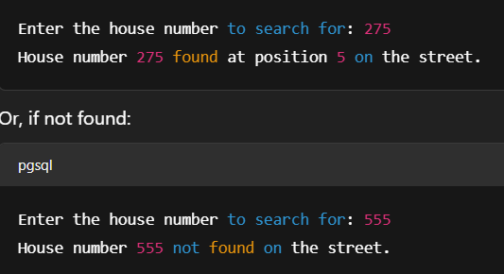

**2. Problem Statement:** When the city planners developed your neighborhood, with numbers for the houses in a sorted order. Write a program using Binary search algorithm to help the postman find a house.

Program:

#include <stdio.h>

// Function to perform binary search

int binarySearch(int houses[], int size, int target) {

int low = 0, high = size - 1;

while (low <= high) {

int mid = (low + high) / 2;

if (houses[mid] == target)

return mid; // Target found

else if (houses[mid] < target)

low = mid + 1; // Search right half

else

high = mid - 1; // Search left half

}

return -1; // Target not found

}

int main() {

// Sorted list of house numbers

int houses[] = {50, 65, 89, 98, 101, 120, 150, 203, 275, 300, 410};

int size = sizeof(houses) / sizeof(houses[0]);

int target;

printf("Enter the house number to search for: ");

scanf("%d", &target);

int result = binarySearch(houses, size, target);

if (result != -1)

printf("House number %d found at position %d on the street.\n", target, result + 1);

else

printf("House number %d not found on the street.\n", target);

return 0;

}

Output:

